**COAL LAB 8**

**Question 1**

Include Irvine32.inc

.data

Arr1 WORD 8, 4, 12, 52, 13, 96, 1, 5, 123, 11

Arr2 WORD 10 dup(?)

.code

Main PROC

MOV ecx, lengthof Arr1

MOV esi, offset Arr1

L1:

push [esi]

ADD esi, type Arr1

Loop L1

MOV esi, offset arr2

MOV ecx, lengthof Arr2

L2:

pop [esi]

ADD esi, type Arr2

Loop L2

MOV ecx, lengthof Arr2

MOV esi, offset Arr2

MOV eax, 0

L3:

MOV ax, [esi]

call writedec

call crlf

ADD esi, type arr2

loop L3

Exit

Main endp

End main

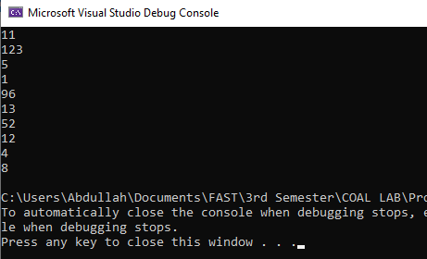

**Question 2**

Include Irvine32.inc

.data

arr1 SDWORD 5, -2, 12, -4, 19

arr2 SDWORD 6, 1, -21, 55, 11

.code

main PROC

MOV esi, OFFSET arr1

MOV edi, OFFSET arr2

MOV ecx, lengthof arr1

call ADDarr1

exit

main endp

ADDarr1 proc uses esi ecx

MOV eax, 0

L1:

ADD eax, [esi]

ADD esi, type arr1

loop L1

call ADDarr2

ret

ADDarr1 endp

ADDarr2 proc uses edi

MOV ebx, 0

MOV ecx, lengthof arr2

L2:

ADD ebx, [edi]

ADD edi, type arr2

loop L2

call DisplaySum

ret

ADDarr2 endp

DisplaySum proc uses eax

ADD eax, ebx

call writeint

ret

DisplaySum endp

end main

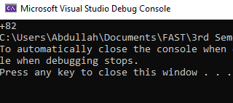

**Question 3**

Include Irvine32.inc

.data

column DWORD ?

count DWORD 1

str1 BYTE "Enter the number of columns: ",0

.code

main proc

mov edx, offset str1

call writestring

call readdec

MOV column, eax

call printpattern

exit

main endp

printpattern PROC

MOV ecx, column

L1:

push ecx

dec ecx

MOV eax, ' '

L2:

cmp ecx, 0

je exitt

call writechar

dec ecx

jmp l2

exitt:

MOV eax, '*'

MOV ecx, count

L3:

call writechar

loop l3

pop ecx

inc count

call crlf

loop l1

ret

printpattern endp

end main

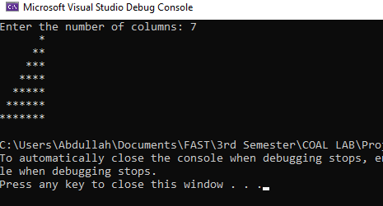

**Question 4**

Include Irvine32.inc

.data

column DWORD ?

count DWORD 1

str1 byte "Enter the number of columns: ",0

.code

main proc

MOV edx, offset str1

call writestring

call readdec

MOV column, eax

call printAlpha

exit

main endp

printAlpha proc

MOV eax, 0

MOV ecx, column

MOV ax, 'A'

L1:

push ecx

push ax

MOV ax, ' '

Dec ecx

MOV ebx, ecx

L2:

cmp ecx, 0

je exitt

call writechar

Dec ecx

jmp L2

exitt:

MOV ecx, count

pop ax

L3:

call writechar

Inc ax

loop L3

pop ecx

inc count

call crlf

loop L1

ret

printAlpha endp

end main

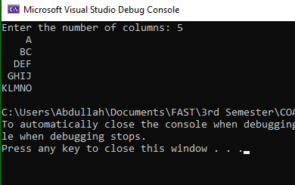

**Question 5**

Include Irvine32.inc

.data

str1 BYTE "Enter a number: ",0

sum DWORD 0

.code

main proc

MOV edx, OFFSET str1

call sumofnumber

exit

main endp

sumofnumber proc uses edx

call writestring

call readdec

MOV ecx, eax

L1:

ADD sum, eax

dec eax

loop L1

MOV eax, sum

call crlf

call writedec

ret

sumofnumber endp

end main

